|  |  |  |  |  |  |
| --- | --- | --- | --- | --- | --- |
| Date | 11-Dec-22 | | | Tester Name | Andrew McLaughlin |
| Environment | Penfax - Test | | | Login used |  |
| Operating System | Select OS | Version: | Update: | | |
| Software Used | Select Software | Version: | Update: | | |
| Select Software | Version: | Update: | | |
| Release version | 22.4.1 | | | | |
| Title | Letters generate | | | | |
| Test Type | Regression | | | | |
| Test Scenario | Letters generate | | | | |
|  |  | | | | |
| Expected Results | * Contents of the Payroll Reduction Report will match the letters generated from the Pension Payment Change Letters batch. * New gross amount in the letters will match members’ new total income. * Letters will be under members’ Communication tab and Outbound Documents. | | | | |
| Pass/Fail | Pass | | | JIRA# | N/A |

Describe your steps with screenshots:

After payroll for the previous month has been run, the Payroll Reduction Report batch process can be run to determine who will have a reduction in the following month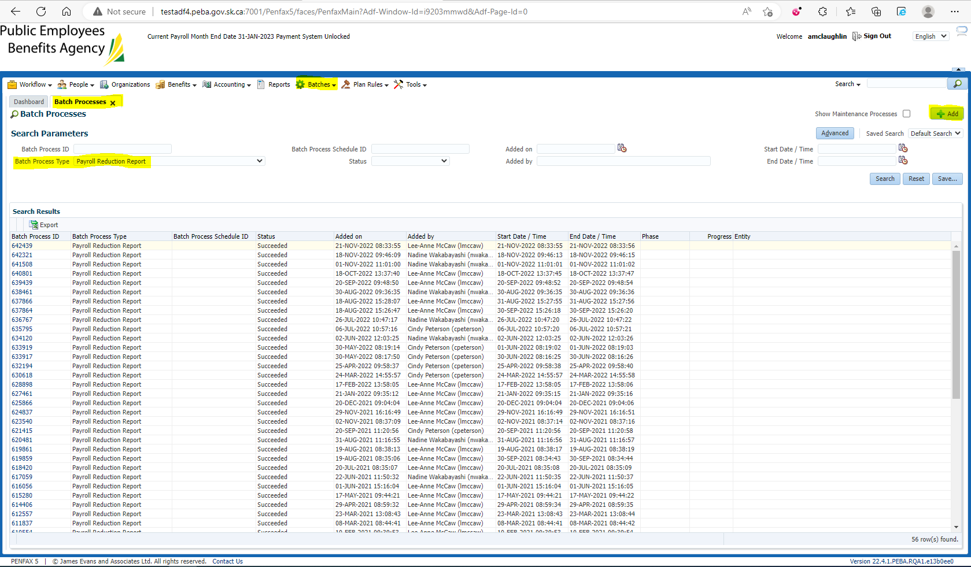

Open the generated batch and open the .csv file to view the members who are receiving reductions next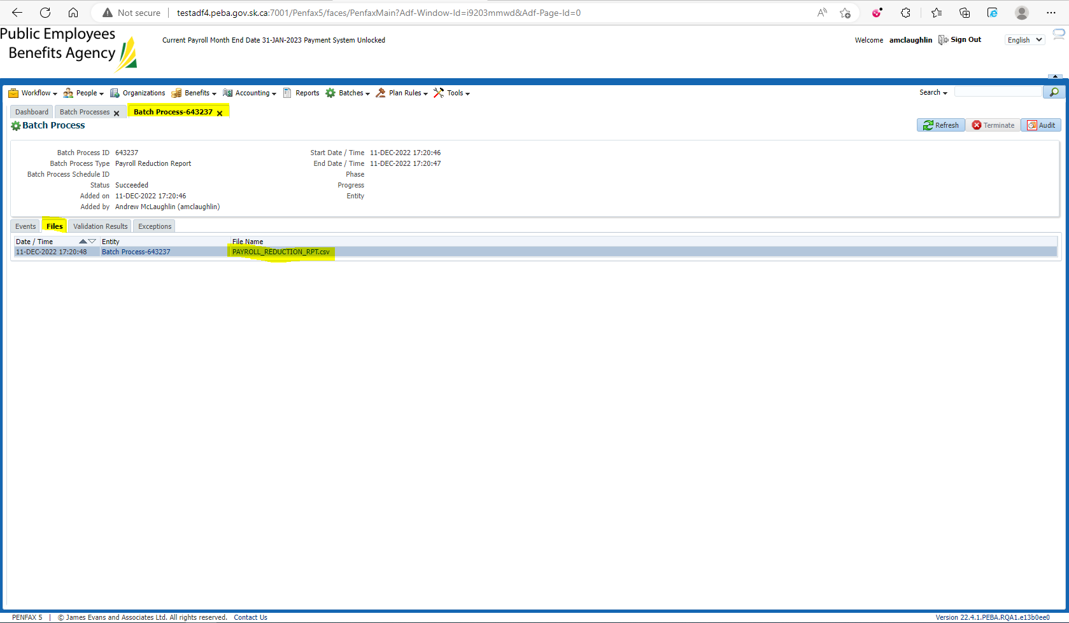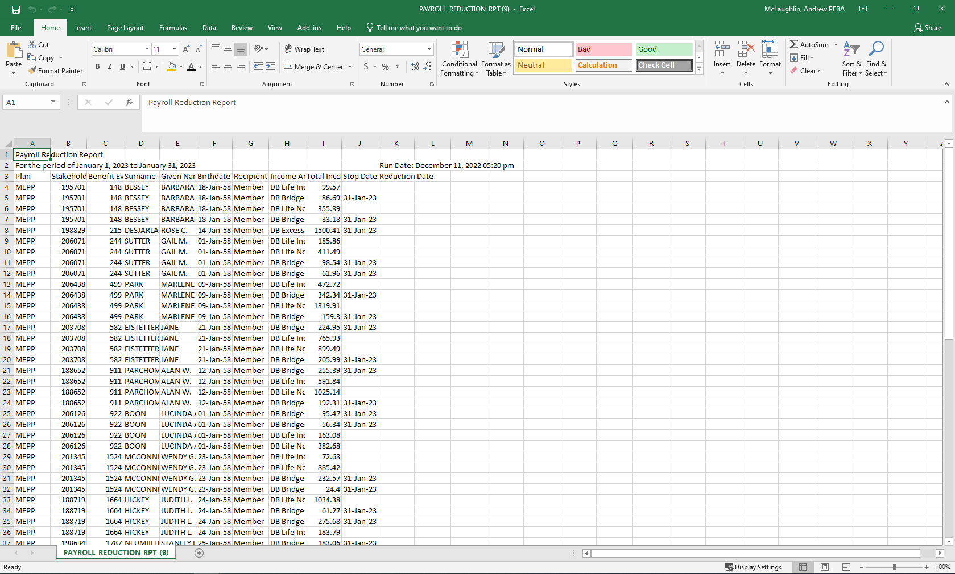

MEPP members automatically have their reductions added to their accounts. Run the Pension Payment Change Letters batch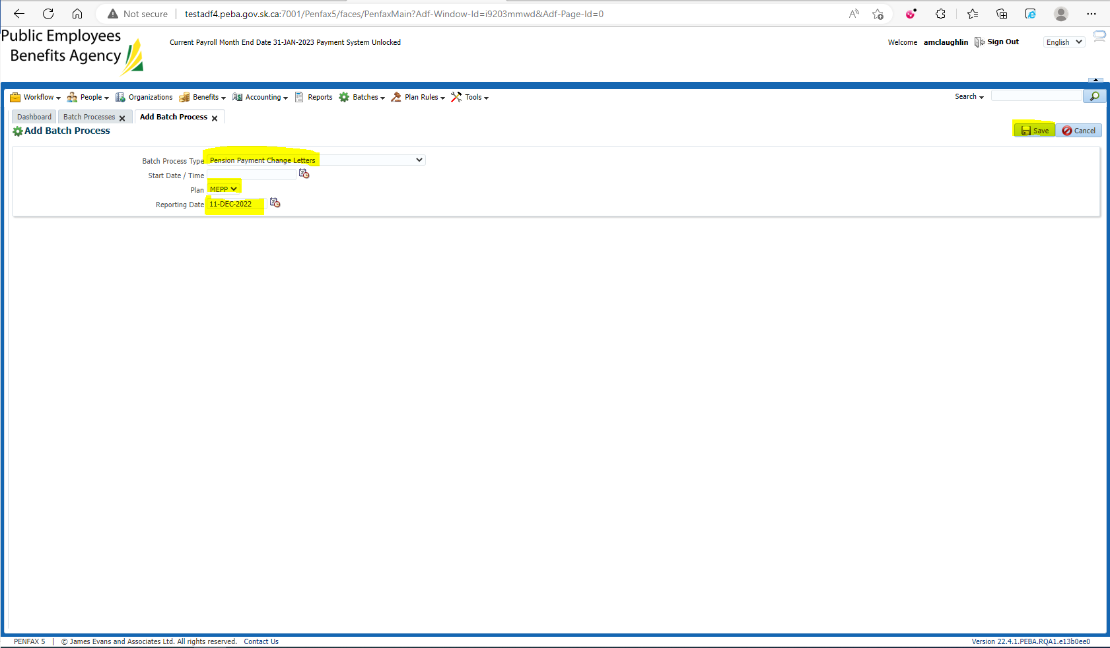

Open the Group PDF to compare against the .csv file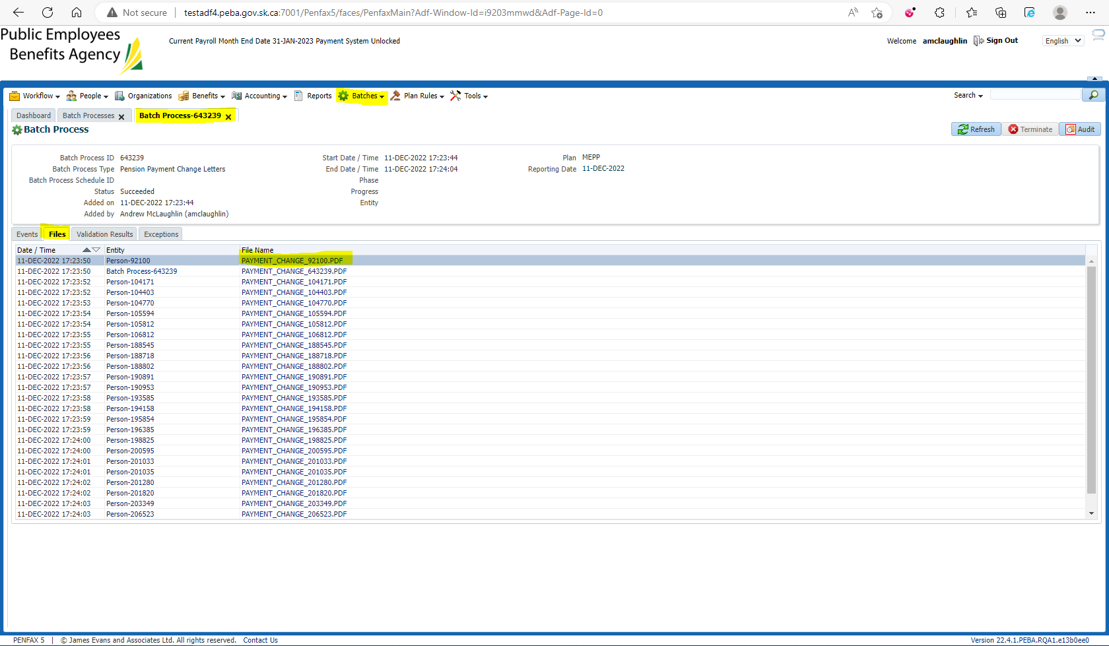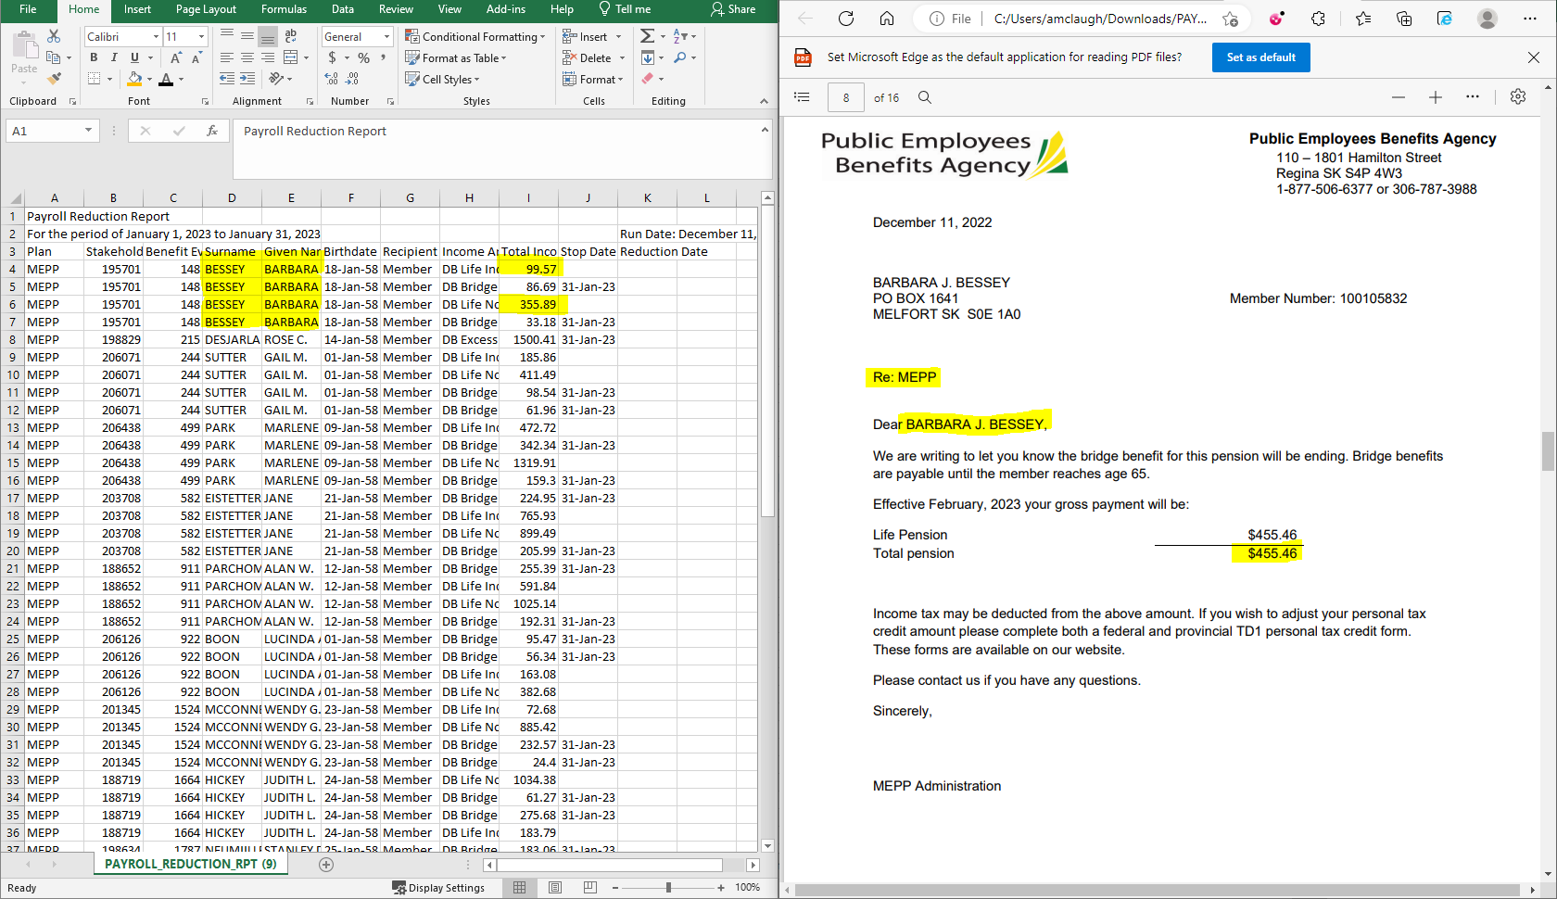

Verify that the letter has been added to the Member’s Outbound Communications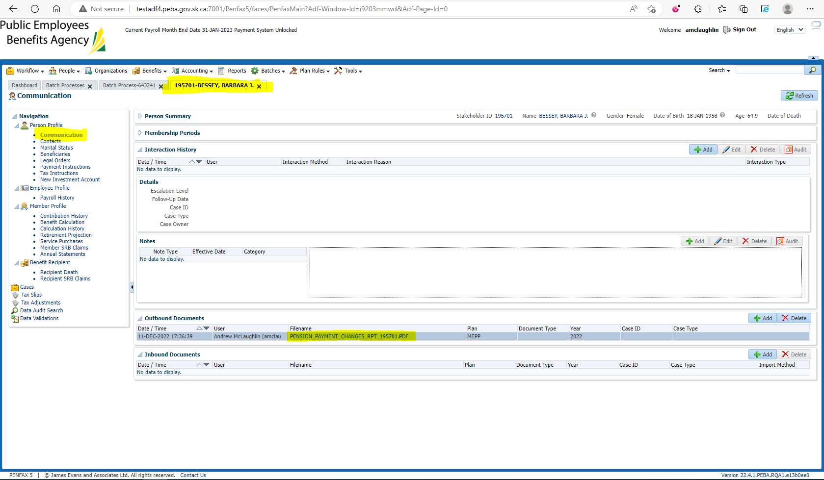

Some of the letters are missing the yellow and green footer line 